**LAB - 4**

**COLOR HISTOGRAM BASED CBIR SYSTEM**

**PRIYANSHU SHARMA**

**15BCE1282**

**Implement a CBIR system that uses features derived from Color Histogram Descriptors.**

**Database – Minimum 10 images and 2 categories Query Image – 1 Similarity Metric –**

**i. Euclidean distance**

**ii. Manhattan distance**

**iii. Correlation**

**iv.Bhattacharya distance**

**v.Chi-squared metric. Search Result - 6**

**CODE -**

**ANSWER - i**

clc

clear all

q=imread('C:\Users\PRIYANSHU SHARMA\Desktop\PRIYANSHU\6 STUDY\MATLAB\LAB 4\1.jpg');

%Creating channels

redChannel = q(:, :, 1);

greenChannel = q(:, :, 2);

blueChannel = q(:, :, 3);

z = zeros(size(q), class(q));

redImage = z; redImage(:,:,1) = redChannel;

greenImage = z; greenImage(:,:,2) = greenChannel;

blueImage = z; blueImage(:,:,3) = blueChannel;

%Get histValues for each channel

[yRed, x] = imhist(redChannel);

[yGreen, x] = imhist(greenChannel);

[yBlue, x] = imhist(blueChannel);

%Getting the hist values

r = imhist(redChannel,32);

g = imhist(greenChannel,32);

b = imhist(blueChannel,32);

h=(r+g+b)/3;

%%DATABASE

fr=[];

srcFiles = dir('C:\Users\PRIYANSHU SHARMA\Desktop\PRIYANSHU\6 STUDY\MATLAB\LAB 4\*.jpg');

srcFiles;

for i=2:10

d = strcat('C:\Users\PRIYANSHU SHARMA\Desktop\PRIYANSHU\6 STUDY\MATLAB\LAB 4\',srcFiles(i).name);

di = imread(d);

%%Creating Channels

redChannels = di(:, :, 1);

greenChannels = di(:, :, 2);

blueChannels = di(:, :, 3);

zd = zeros(size(di), class(di));

redImaged = zd; redImaged(:,:,1) = redChannels;

greenImaged = zd; greenImaged(:,:,2) = greenChannels;

blueImaged = zd; blueImaged(:,:,3) = blueChannels;

%Getting the hist values

rd = imhist(redChannels,32);

gd = imhist(greenChannels,32);

bd = imhist(blueChannels,32);

%mean

hi=(rd+gd+bd)/3;

%Euclidean Distance

fr(i) = sqrt(sum((h-hi).^2));;

end

clear min;

ra = [];

fr(1)=[];

fr;

ascen=sort(fr);

ascen;

[m,n] = size(fr);

for k=1:n

mini=min(fr);

ra(k)=find(fr==ascen(k))+1;

fr;

end

ra;

for i=1:9

name = strcat(num2str(ra(i)),'.jpg');

filename = strcat('C:\Users\PRIYANSHU SHARMA\Desktop\PRIYANSHU\6 STUDY\MATLAB\LAB 4\',name);

result = imread(filename);

figure;

image(result);

end

fr

ascen

ra

**RESULT**

fr = 1.0500 1.0409 1.0854 1.0283 1.0255 1.0350 1.0450 1.0294 1.0482

ascen = 1.0255 1.0283 1.0294 1.0350 1.0409 1.0450 1.0482 1.0500 1.0854

ra = 6 5 9 7 3 8 10 2 4

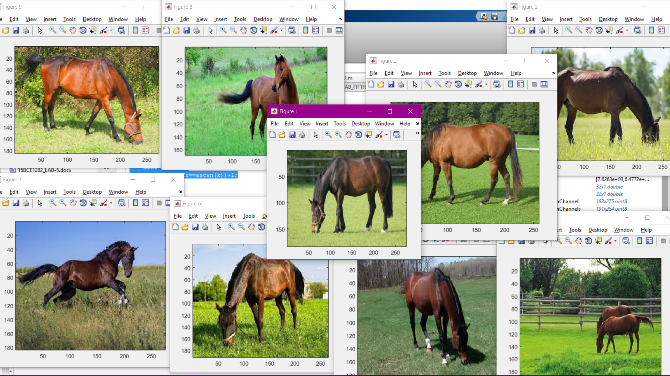

ALL THE RESULTANT IMAGES ARE RETRIEVE FROM THE IMAGE DATABASE

**ANSWER - ii**

clc

clear all

q=imread('C:\Users\PRIYANSHU SHARMA\Desktop\PRIYANSHU\6 STUDY\MATLAB\LAB 4\1.jpg');

%Creating channels

redChannel = q(:, :, 1);

greenChannel = q(:, :, 2);

blueChannel = q(:, :, 3);

z = zeros(size(q), class(q));

redImage = z; redImage(:,:,1) = redChannel;

greenImage = z; greenImage(:,:,2) = greenChannel;

blueImage = z; blueImage(:,:,3) = blueChannel;

%Get histValues for each channel

[yRed, x] = imhist(redChannel);

[yGreen, x] = imhist(greenChannel);

[yBlue, x] = imhist(blueChannel);

%Getting the hist values

r = imhist(redChannel,32);

g = imhist(greenChannel,32);

b = imhist(blueChannel,32);

h=(r+g+b)/3;

%%DATABASE

fr=[];

srcFiles = dir('C:\Users\PRIYANSHU SHARMA\Desktop\PRIYANSHU\6 STUDY\MATLAB\LAB 4\*.jpg');

srcFiles;

for i=2:10

d = strcat('C:\Users\PRIYANSHU SHARMA\Desktop\PRIYANSHU\6 STUDY\MATLAB\LAB 4\',srcFiles(i).name);

di = imread(d);

%%Creating Channels

redChannels = di(:, :, 1);

greenChannels = di(:, :, 2);

blueChannels = di(:, :, 3);

zd = zeros(size(di), class(di));

redImaged = zd; redImaged(:,:,1) = redChannels;

greenImaged = zd; greenImaged(:,:,2) = greenChannels;

blueImaged = zd; blueImaged(:,:,3) = blueChannels;

%Getting the hist values

rd = imhist(redChannels,32);

gd = imhist(greenChannels,32);

bd = imhist(blueChannels,32);

%mean

hi=(rd+gd+bd)/3;

%Manhattan Distance

fr(i) = sum(abs(h-hi));

end

clear min;

ra = [];

fr(1)=[];

fr;

ascen=sort(fr);

ascen;

[m,n] = size(fr);

for k=1:n

mini=min(fr);

ra(k)=find(fr==ascen(k))+1;

fr;

end

ra;

for i=1:9

name = strcat(num2str(ra(i)),'.jpg');

filename = strcat('C:\Users\PRIYANSHU SHARMA\Desktop\PRIYANSHU\6 STUDY\MATLAB\LAB 4\',name);

result = imread(filename);

figure;

image(result);

end

fr

ascen

ra

**RESULT**

fr = 1.0e+04 *

3.1653 2.9158 4.6434 2.2229 2.1525 2.2276 3.3021 2.2149 3.2024

ascen = 1.0e+04 *

2.1525 2.2149 2.2229 2.2276 2.9158 3.1653 3.2024 3.3021 4.6434

ra = 6 9 5 7 3 2 10 8 4

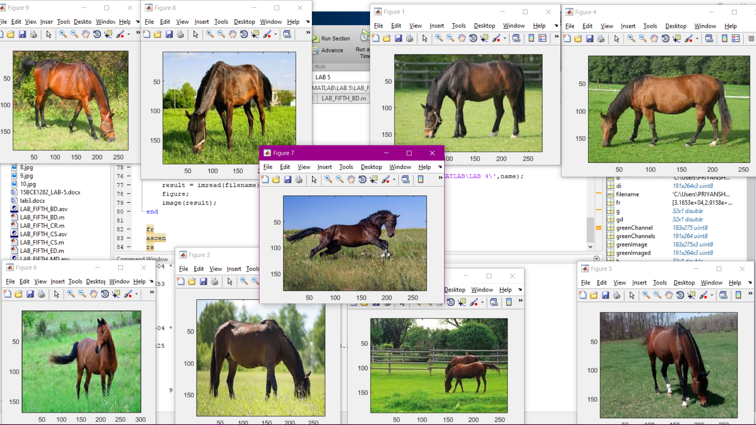

ALL THE RESULTANT IMAGES ARE RETRIEVE FROM THE IMAGE DATABASE

**ANSWER - iii**

clc

clear all

q=imread('C:\Users\PRIYANSHU SHARMA\Desktop\PRIYANSHU\6 STUDY\MATLAB\LAB 4\1.jpg');

%Creating channels

redChannel = q(:, :, 1);

greenChannel = q(:, :, 2);

blueChannel = q(:, :, 3);

z = zeros(size(q), class(q));

redImage = z; redImage(:,:,1) = redChannel;

greenImage = z; greenImage(:,:,2) = greenChannel;

blueImage = z; blueImage(:,:,3) = blueChannel;

%Get histValues for each channel

[yRed, x] = imhist(redChannel);

[yGreen, x] = imhist(greenChannel);

[yBlue, x] = imhist(blueChannel);

%Getting the hist values

r = imhist(redChannel,32);

g = imhist(greenChannel,32);

b = imhist(blueChannel,32);

srhq = sum(r);

sghq = sum(g);

sbhq = sum(b);

ssrhq = sum(r.^2);

ssghq = sum(g.^2);

ssbhq = sum(b.^2);

%%DATABASE

fr=[];

srcFiles = dir('C:\Users\PRIYANSHU SHARMA\Desktop\PRIYANSHU\6 STUDY\MATLAB\LAB 4\*.jpg');

srcFiles;

for i=2:10

d = strcat('C:\Users\PRIYANSHU SHARMA\Desktop\PRIYANSHU\6 STUDY\MATLAB\LAB 4\',srcFiles(i).name);

di = imread(d);

%%Creating Channels

redChannels = di(:, :, 1);

greenChannels = di(:, :, 2);

blueChannels = di(:, :, 3);

zd = zeros(size(di), class(di));

redImaged = zd; redImaged(:,:,1) = redChannels;

greenImaged = zd; greenImaged(:,:,2) = greenChannels;

blueImaged = zd; blueImaged(:,:,3) = blueChannels;

%Getting the hist values

rh = imhist(redChannels,32);

gh = imhist(greenChannels,32);

bh = imhist(blueChannels,32);

srh = sum(rh);

sgh = sum(gh);

sbh = sum(bh);

ssrh = sum(rh.^2);

ssgh = sum(gh.^2);

ssbh = sum(bh.^2);

sopr = sum(rh.*r);

sopg = sum(gh.*g);

sopb = sum(bh.*b);

numr = ((srh*srhq)/2) - sopr;

numg = ((sgh*sghq)/2) - sopg;

numb = ((sbh*sbhq)/2) - sopb;

denr = sqrt((ssrhq - (srhq^2)/2)*(ssrh - (srh^2)/2));

deng = sqrt((ssghq - (sghq^2)/2)*(ssgh - (sgh^2)/2));

denb = sqrt((ssbhq - (sbhq^2)/2)*(ssbh - (sbh^2)/2));

cr = numr/(denr+1);

cg = numg/(deng+1);

cb = numb/(denb+1);

fr(i) = (mean([cr cg cb]));

end

clear min;

ra = [];

fr(1)=[];

fr;

ascen=sort(fr);

ascen;

[m,n] = size(fr);

for k=1:n

mini=min(fr);

ra(k)=find(fr==ascen(k))+1;

fr;

end

ra;

for i=1:9

name = strcat(num2str(ra(i)),'.jpg');

filename = strcat('C:\Users\PRIYANSHU SHARMA\Desktop\PRIYANSHU\6 STUDY\MATLAB\LAB 4\',name);

result = imread(filename);

figure;

image(result);

end

fr

ascen

ra

**RESULT**

fr = 1.0500 1.0409 1.0854 1.0283 1.0255 1.0350 1.0450 1.0294 1.0482

ascen = 1.0255 1.0283 1.0294 1.0350 1.0409 1.0450 1.0482 1.0500 1.0854

ra = 6 5 9 7 3 8 10 2 4

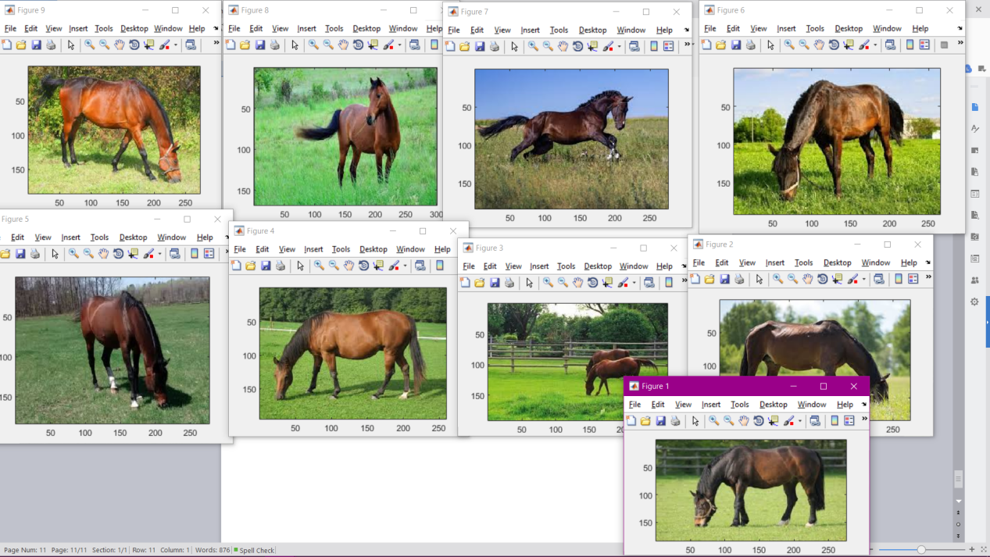

ALL THE RESULTANT IMAGES ARE RETRIEVE FROM THE IMAGE DATABASE

**ANSWER - iv**

clc

clear all

q=imread('C:\Users\PRIYANSHU SHARMA\Desktop\PRIYANSHU\6 STUDY\MATLAB\LAB 4\1.jpg');

%Creating channels

redChannel = q(:, :, 1);

greenChannel = q(:, :, 2);

blueChannel = q(:, :, 3);

z = zeros(size(q), class(q));

redImage = z; redImage(:,:,1) = redChannel;

greenImage = z; greenImage(:,:,2) = greenChannel;

blueImage = z; blueImage(:,:,3) = blueChannel;

%Get histValues for each channel

[yRed, x] = imhist(redChannel);

[yGreen, x] = imhist(greenChannel);

[yBlue, x] = imhist(blueChannel);

%Getting the hist values

r = imhist(redChannel,32);

g = imhist(greenChannel,32);

b = imhist(blueChannel,32);

%%DATABASE

fr=[];

srcFiles = dir('C:\Users\PRIYANSHU SHARMA\Desktop\PRIYANSHU\6 STUDY\MATLAB\LAB 4\*.jpg');

srcFiles;

for i=2:10

d = strcat('C:\Users\PRIYANSHU SHARMA\Desktop\PRIYANSHU\6 STUDY\MATLAB\LAB 4\',srcFiles(i).name);

di = imread(d);

%%Creating Channels

redChannels = di(:, :, 1);

greenChannels = di(:, :, 2);

blueChannels = di(:, :, 3);

zd = zeros(size(di), class(di));

redImaged = zd; redImaged(:,:,1) = redChannels;

greenImaged = zd; greenImaged(:,:,2) = greenChannels;

blueImaged = zd; blueImaged(:,:,3) = blueChannels;

%Getting the hist values

rd = imhist(redChannels,32);

gd = imhist(greenChannels,32);

bd = imhist(blueChannels,32);

rf = -log(sum((r.*rd).^0.5));

gf = -log(sum((g.*gd).^0.5));

bf = -log(sum((b.*bd).^0.5));

%Bhattacharya Distance

fr(i) = mean([rf gf bf]);

end

clear min;

ra = [];

fr(1)=[];

fr;

ascen=sort(fr);

ascen;

[m,n] = size(fr);

for k=1:n

mini=min(fr);

ra(k)=find(fr==ascen(k))+1;

fr;

end

ra;

for i=1:9

name = strcat(num2str(ra(i)),'.jpg');

filename = strcat('C:\Users\PRIYANSHU SHARMA\Desktop\PRIYANSHU\6 STUDY\MATLAB\LAB 4\',name);

result = imread(filename);

figure;

image(result);

end

fr

ascen

ra

**RESULT**

fr = -10.6622 -10.6738 -10.5771 -10.7176 -10.7447 -10.7174 -10.6842 -10.7564 -10.6916

ascen = -10.7564 -10.7447 -10.7176 -10.7174 -10.6916 -10.6842 -10.6738 -10.6622 -10.5771

ra = 9 6 5 7 10 8 3 2 4

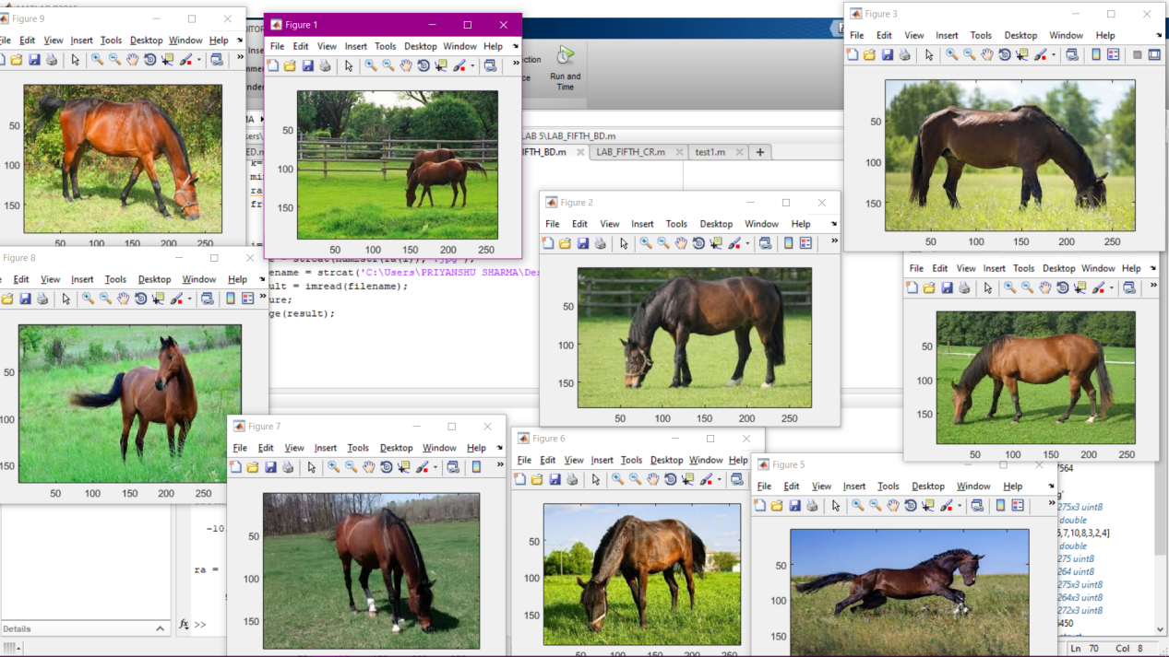

ALL THE RESULTANT IMAGES ARE RETRIEVE FROM THE IMAGE DATABASE

**ANSWER - v**

clc

clear all

q=imread('C:\Users\PRIYANSHU SHARMA\Desktop\PRIYANSHU\6 STUDY\MATLAB\LAB 4\1.jpg');

%Creating channels

redChannel = q(:, :, 1);

greenChannel = q(:, :, 2);

blueChannel = q(:, :, 3);

z = zeros(size(q), class(q));

redImage = z; redImage(:,:,1) = redChannel;

greenImage = z; greenImage(:,:,2) = greenChannel;

blueImage = z; blueImage(:,:,3) = blueChannel;

%Get histValues for each channel

[yRed, x] = imhist(redChannel);

[yGreen, x] = imhist(greenChannel);

[yBlue, x] = imhist(blueChannel);

%Getting the hist values

r = imhist(redChannel,32);

g = imhist(greenChannel,32);

b = imhist(blueChannel,32);

%%DATABASE

fr=[];

srcFiles = dir('C:\Users\PRIYANSHU SHARMA\Desktop\PRIYANSHU\6 STUDY\MATLAB\LAB 4\*.jpg');

srcFiles;

for i=2:10

d = strcat('C:\Users\PRIYANSHU SHARMA\Desktop\PRIYANSHU\6 STUDY\MATLAB\LAB 4\',srcFiles(i).name);

di = imread(d);

%%Creating Channels

redChannels = di(:, :, 1);

greenChannels = di(:, :, 2);

blueChannels = di(:, :, 3);

zd = zeros(size(di), class(di));

redImaged = zd; redImaged(:,:,1) = redChannels;

greenImaged = zd; greenImaged(:,:,2) = greenChannels;

blueImaged = zd; blueImaged(:,:,3) = blueChannels;

%Getting the hist values

rd = imhist(redChannels,32);

gd = imhist(greenChannels,32);

bd = imhist(blueChannels,32);

rf = ((r-rd).^2)./(r+rd);

gf = ((g-gd).^2)./(g+gd);

bf = ((b-bd).^2)./(b+bd);

sr = sum(rf);

sg = sum(gf);

sb = sum(bf);

%Chi Square Distance

fr(i) = mean([sr sg sb]);

end

clear min;

ra = [];

fr(1)=[];

fr;

ascen=sort(fr);

ascen;

[m,n] = size(fr);

for k=1:n

mini=min(fr);

ra(k)=find(fr==ascen(k))+1;

fr;

end

ra;

for i=1:9

name = strcat(num2str(ra(i)),'.jpg');

filename = strcat('C:\Users\PRIYANSHU SHARMA\Desktop\PRIYANSHU\6 STUDY\MATLAB\LAB 4\',name);

result = imread(filename);

figure;

image(result);

end

fr

ascen

ra

**RESULT**

fr = 1.0e+04 *

2.2873 2.0440 3.3126 1.5664 1.3752 1.5738 2.0824 1.2616 2.0997

ascen = 1.0e+04 *

1.2616 1.3752 1.5664 1.5738 2.0440 2.0824 2.0997 2.2873 3.3126

ra = 9 6 5 7 3 8 10 2 4

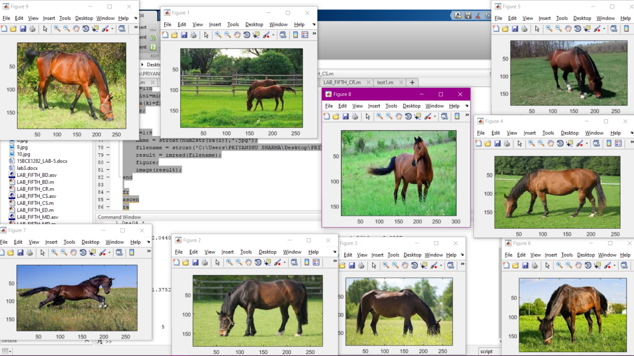

ALL THE RESULTANT IMAGES ARE RETRIEVE FROM THE IMAGE DATABASE